Use Case Specification

DMT/RM01/TMP

|  |  |
| --- | --- |
| Project Code | PRJ_HotelManagement_001 |
| Project Name | Hotel Management |

|  |  |  |
| --- | --- | --- |
| Prepared/Modified by | Role | Date of Preparation |
| Harshita Ahuja | Test Engineer | 20/10/2018 |
| Reviewed by | Role | Date of Review |
| Himanshu,Ijas,Kartik | SME |  |
| Approved by | Role | Date of Approval |
| Christy | Test Manager |  |
| Circulation List |  | Version Number of the template: |
| Version Number | 1 |  |

<<Customer>> REVIEW HISTORY

<<Customer comments on the Use case along with the signed off is tracked here>>

|  |  |  |  |  |  |  |
| --- | --- | --- | --- | --- | --- | --- |
| Version | <<Version number>> |  |  |  |  |  |
| Date | <<Date of Review>> |  |  |  |  |  |
| Reviewed by | << Reviewer Name>> |  |  |  |  |  |
| Reviewed UI Specification doc | << Whether UI Specification doc is reviewed >> |  |  |  |  |  |
| All Open Queries/issues closed | << Whether all the open queries and issues resolved>> |  |  |  |  |  |
| Agreement on Assumptions | <<Whether all the assumptions have been agreed upon by the customer>> |  |  |  |  |  |
| Sign Off | <<Signature>> |  |  |  |  |  |

Disclaimer:

The scope of the project ‘<<Project Name>>’ is restricted to the contents of this signed off use case.

**TABLE OF CONTENTS**

1. Use case Name 4
2. Actor(s) 4
3. Preconditions 4
4. Flow of events 4
   1. Basic Flow 4
5. Exception Flow
   1. Exception Flow 1 5
   2. Exception Flow 2 5
   3. Exception Flow 3 5
6. Post Conditions 6
7. Special Requirements
   1. Availability 6
   2. Business Rules 6
8. Diagrams
   1. Use Case Diagram
      1. For Successful Booking 7
9. Scenarios
   1. Success Scenarios 7
   2. Failure Scenarios 8
10. Issues 8
11. UI Specifications 9
12. Assumptions 9
13. Revision History of the work product 10

Use Case Name: Hotel Management system

**Use Case ID:**HotelManagement1.0

**Brief Description:**This usecase describes about booking of the hotel rooms..

2. Actor(s)

1. Customer.

2. Employee

3. Hotel Management System.

1. Preconditions
2. The user has successfully login into the site <http://ndafile:8081/Spring_Hotel/login.html>.

4. Flow of Events

4.1 Basic Flow

**Name: Sucessfully booking of hotel room**.

1. User enters No. of rooms to be booked.
2. User enters No. of adults.
3. User enters No. of children..
4. User clicks on Book button.
5. System will display the message “Your room is booked”.

Exception Flow

Exception Flow 1: Web Server Down

1. User enters No. of rooms to be booked.
2. User enters No. of adults.
3. User enters No. of children..
4. User clicks on Book button.
5. The system displays an error message regarding web server unavailability problem

Exception Flow 2: Database Connectivity Error

1. User enters No. of rooms to be booked.
2. User enters No. of adults.
3. User enters No. of children..
4. User clicks on Book button.
5. The system displays an error message regarding database connectivity problem.

Exception Flow 3: Network Connectivity Error

1. User enters No. of rooms to be booked.
2. User enters No. of adults.
3. User enters No. of children..
4. User clicks on Book button.
5. The system displays an error message regarding network connectivity problem.

Post Conditions

| **Flow Name** | **Post Condition** |
| --- | --- |
| Successful booking of hotel room. | System displays the message “ Your room is booked”. |
| Web Server Down | The system should display an error message to the user regarding web server unavailability problem |
| Database Connectivity Error | The system should display an error message to the user regarding the database connectivity problem |
| Network Connectivity Error | The system should display an error message to the user regarding the network connectivity problem |

Special Requirements

Availability

* 1. Application is up and running 24*7.

Business Rules

| **Business Rule Name** | **Business Rule Description** | **System action (if BR fails)** |
| --- | --- | --- |
| BR01 | To enter No. of rooms to be booked is compulsory. | Error message will get displayed if it is not done”. |

Diagrams

Use Case Diagram

For Successful Adding hotels

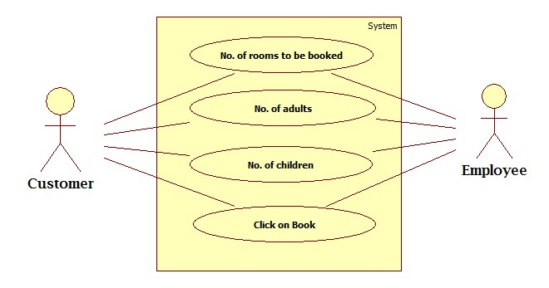

Scenarios

Success Scenarios

* Successful in booking hotel rooms.

Failure Scenarios

* Failed submission in updation of hotel due to web server down.
* Failed submission in updation of hotel due to database connectivity.
* Failed submission in updation of hotel due to network error.

Issues

1. What is to be done if web server is down?
2. What is to be done if there is data connectivity error?
3. What is to be done if room is not booked?

UI Specifications

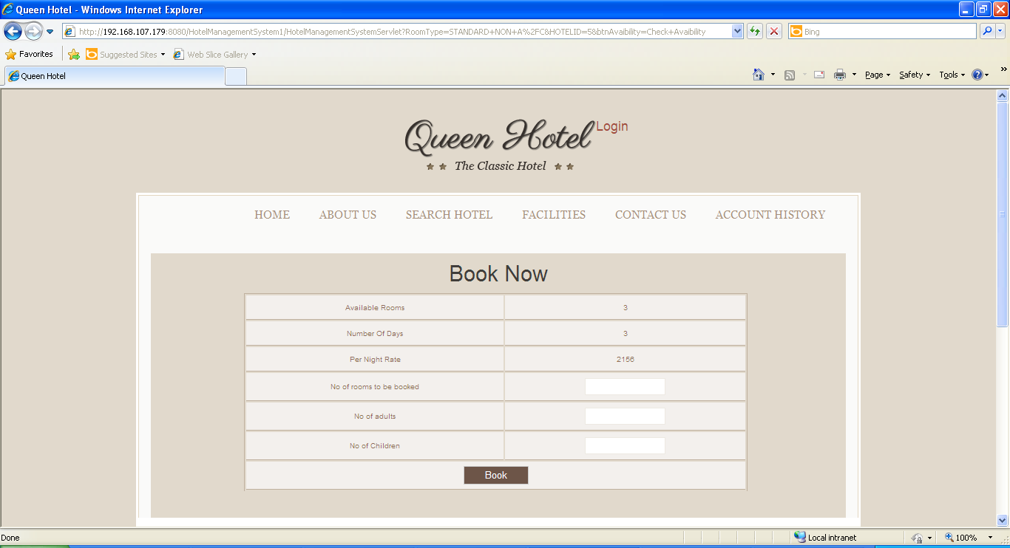

Assumptions

* 1. Only registered users can book the room in the Hotel.

REVISION HISTORY OF THE WORK PRODUCT

<to be maintained by projects>

|  |  |  |  |  |  |
| --- | --- | --- | --- | --- | --- |
| # | Date | Version # | Section Changed | Details of changes made | Approved By |
| 1 |  |  |  |  |  |
| 2 |  |  |  |  |  |